
PROFESSIONAL DEVELOPMENT 4

Test 1

Name: Moipone
Surname: Kabai
Student number: 215203569
Stream: AppDev

Due date: 21 June 2020
Question 1
1.1
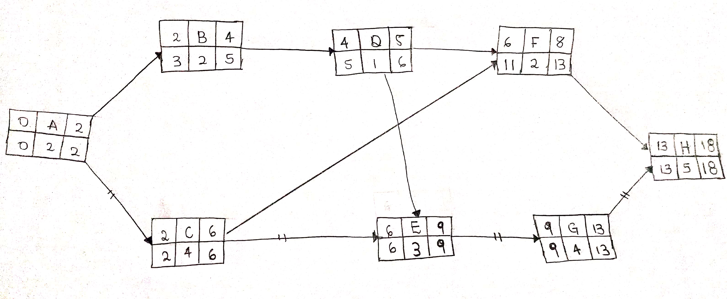
1.2) 18 days
Critical path = A, C, E, G, H
1.3)
Floats = LS – ES
=13 – 11
= 2
E - D = 6 – 5
= 1
1.4) Critical path is the longest path through the project network. The activities on the critical path represents task that may delay the entire project if not complete on time. The critical path helps to determine the expected project completion time, and allows teams to identify the most important activities in a project. This provides a higher level of insight into your project's timeline and a correlation between tasks, giving you more understanding about which task durations you can modify, and which must stay the same.
Question 2
2.1
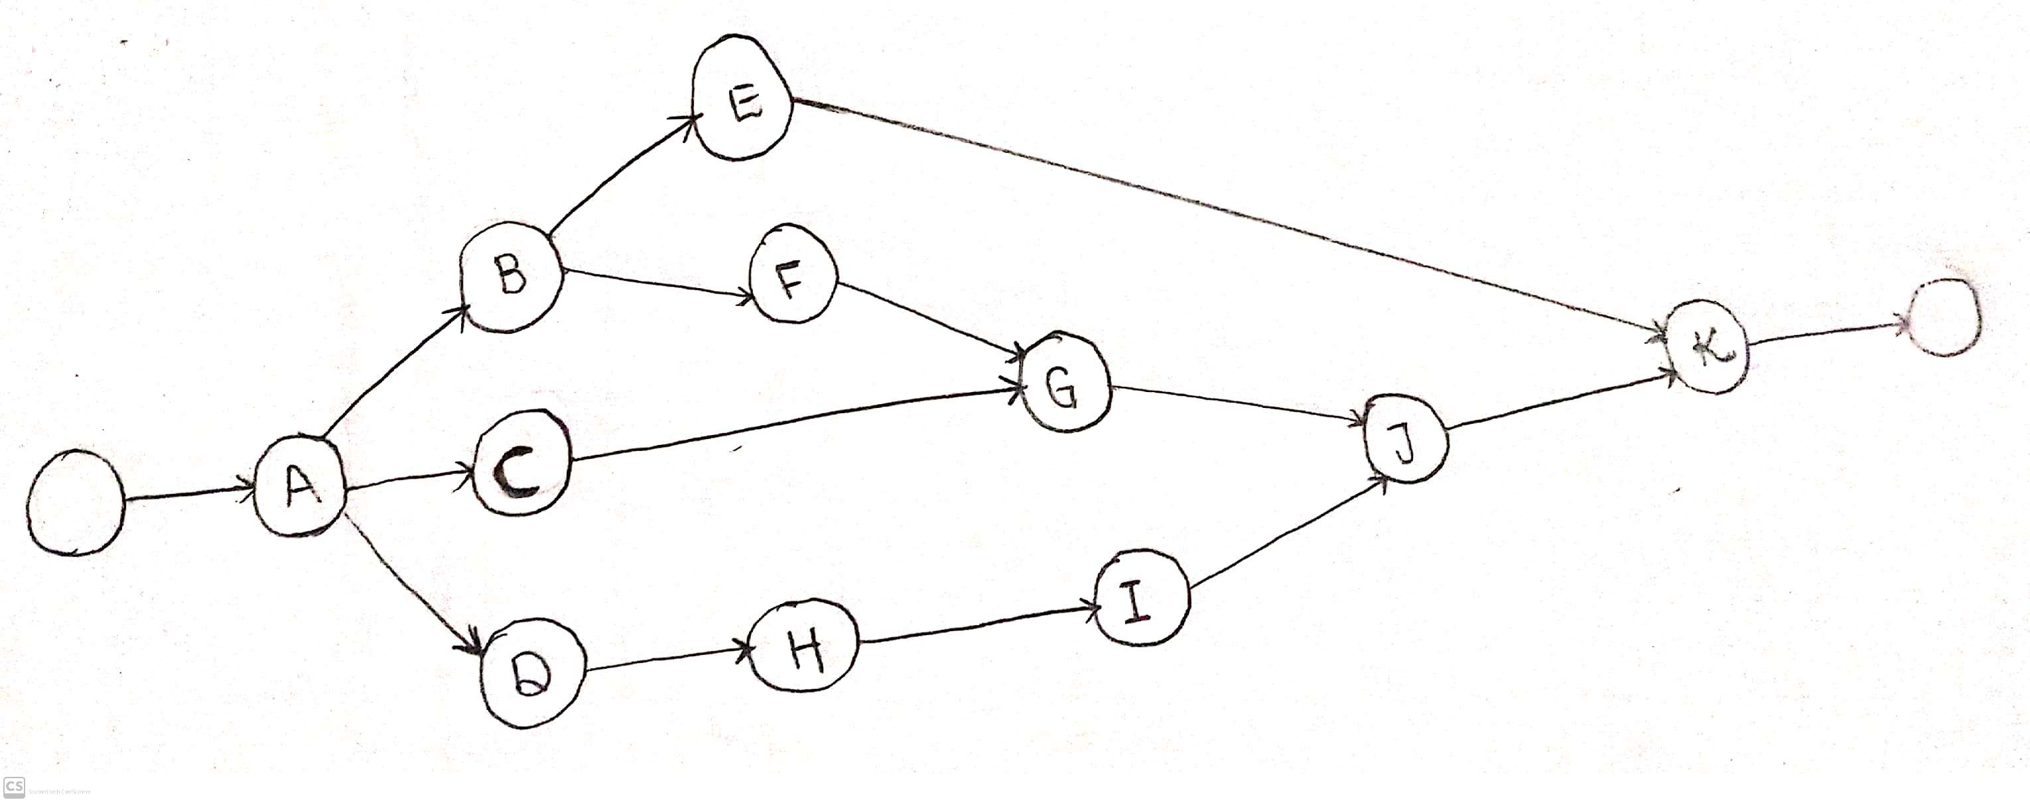
2.2)
A = (1-3/6) ^2
= 0.11
D = (4-10/6) ^2
= 1
H = (4-10/6) ^2
= 1
I = (4-12/6) ^2
= 1.77
J = (9-13/6) ^2
= 0.44
K = (3-10/6) ^2
= 1.36
A = 0.11, D = 1, H = 1, I = 1.77, J = 0.44, K = 1.36
Critical path = A, D, H, I, J, K
S^2 = 5.68
S = √5.68
= 2.38
µ = 58
2.3)
P (Z) = 0.99
P (Z=X) = 2.325
Z = X - µ/s = 2.325
X – 42.5 = 12.76425
X = 12.76425 + 42.5
X = 55.26 days
Therefore there is a 0.99 probability that the project will be finished in 56 days.
Question 3
3.1 Project management is the application of knowledge, skills, tools and techniques to project activities to meet project requirements. It is accomplished through the application and integration of the project management processes of initiating, planning, executing, monitoring and controlling, and closing.
Characteristics of project:
- Temporary: means that every project has a definite beginning and a definite end. The end is reached when the project’s objectives have been achieved, or it becomes clear that the project objectives will not or cannot be met.
- Unique products, services or results: A capability to perform a service, such as business functions supporting production or distribution.
- Progressive Elaboration: A characteristic of projects that accompanies the concepts of temporary and unique. It means developing in steps, and continuing by increments.
3.2 A fundamental tradeoff is a project constraint that is often known as the iron triangle. Trade-offs are the result of a process where the team evaluates options for the project and decides which approach best meets the project's goals. Project managers are faced with difficult situations where the company wants more than can be achieved within the time or cost or resource constraints.
3.3
- Specialization of labor: Specializing encourages continuous improvement in skills and the development of improvements in methods.
- Authority: The right to give orders and the power to exact obedience.
- Discipline: No slacking, bending of rules.
- Unity of command: Each employee has one and only one boss.
- Unity of direction: A single mind generates a single plan and all play their part in that plan.
- Subordination of Individual Interests: When at work, only work things should be pursued or thought about.
- Remuneration: Employees receive fair payment for services, not what the company can get away with.
- Centralization: Consolidation of management functions. Decisions are made from the top.
- Scalar Chain (line of authority): Formal chain of command running from top to bottom of the organization, like military
- Order: All materials and personnel have a prescribed place, and they must remain there.
- Equity: Equality of treatment (but not necessarily identical treatment)
- Personnel Tenure: Limited turnover of personnel. Lifetime employment for good workers.
- Initiative: Thinking out a plan and do what it takes to make it happen.
- Esprit de corps: Harmony, cohesion among personnel.
Henri’s principles could be used as a framework for identifying some of the changes that companies, should be making in order to increase the effectiveness of their management practices. Thus, Fayol's principles of management are still applicable in management and they will continue to provide general perspectives for practicing managers.
3.4
Interpersonal Roles
- Figurehead
- Leader
- Liaison
Informational Roles (40%)
- Monitor
- Disseminator
- Spokesperson
Decisional Roles
- Entrepreneur
- Disturbance Handler
- Resource Allocator
- Negotiator
This is applicable to managers because according to Mintzberg, these roles are expectations for a manager’s behavior.
Question 4
4.1)
8hours * 5days * R150 = R6 000
4.2)
8hours * 6days * R150 = R7 200
8hours * 6days * R200 = R9 600
8hours * 6days * R250 = R12 000
8hours * 6days * R100 = R4 800
8hours * 6days * R170 = R8 160
Total in 6 days = R41 760
4.3)
8hours * 14days * R150 = R16 800
8hours * 14days * R200 = R22 400
8hours * 14days * R250 = R28 000
8hours * 14days * R100 = R11 200
8hours * 14days * R170 = R19 040
Total in 14 days = R97 440
Question 5
5.1) Payback period = Cost of project / Annual Cash Flow
=200 000/40 000
=5 years
5.2)
PV1 = FV / (1+i) ^n
= R40 000 / (1+0.12) ^1
= R35 714.29
PV2 = FV / (1+i) ^n
= R40 000 / (1+0.12) ^2
= R31 887.76
PV3 = FV / (1+i) ^n
= R40 000 / (1+0.12) ^3
= R28 471.21
PV4 = FV / (1+i) ^n
= R40 000 / (1+0.12) ^4
= R25 420.72
PV2 = FV / (1+i) ^n
= R40 000 / (1+0.12) ^5
= R22 697.07
Total PV = R144 191.05
Therefore, NVP = -R200 000 + R-55 808.95
So, if NVP < 0 the project should be rejected by the project manager.
5.3) O=Cash Flows – Investments

Discount Rate at 1%
Year | Cash Flow | Interest Factor | Present Value
0 | -R200000.00 | 1 | -R200 000.00
1 | R40 000.00 | 0.9900990099 | R39 603.96
2 | R40 000.00 | 0.9802960494 | R39 211.84
3 | R40 000.00 | 0.9705901479 | R38 823.61
4 | R40 000.00 | 0.9609803445 | R38 439.21
5 | R40 000.00 | 0.9514656876 | R38 058.63
 |  | Net Present Value | -R5 862.75

